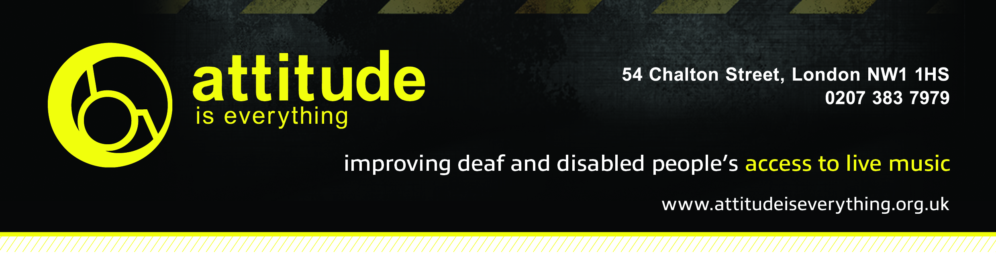

Access Starts Online – Festival Access Info Template

Check out our Festival Access Info Guide for tips on what to include under each section.

- Introduction

- Contact Details

- Download link for all access info
- Site Description

- Bookable Access Facilities

- How To Apply

Note: If accessible camping, parking or access to viewing platforms does not require booking, include separate sections on these topics.

- Travel Guide

- Arrival Guide

- Toilets

- Medical Services

- Access to Performance

- Assistance Dogs

- Strobe Lighting

